Soft Links and Hard Links

|  |  |
| --- | --- |
| **Soft Links** | **Hard Links** |
| Soft Links are invalid once the source or parent file is deleted | Removing source file won’t affect  Hard links because they share same inode number, permissions and data of the original file |
| Soft link is just a link that points to the original file yet with a different inode number and file permissions | Hard link and source file have same inode number and file permissions |
| Soft link is a shortcut to a cut, if you remove the source file, the shortcut becomes useless | If we change permissions on a source file, the same permissions will be applied to hard link. |
| If a soft link is removed, the original file is still available | If a hard link is removed, the original file is still available |

**Soft Links**

Let’s create two new files:

user$ touch file1.txt file2.txt

Now let’s see the current directory

user$ ls –li

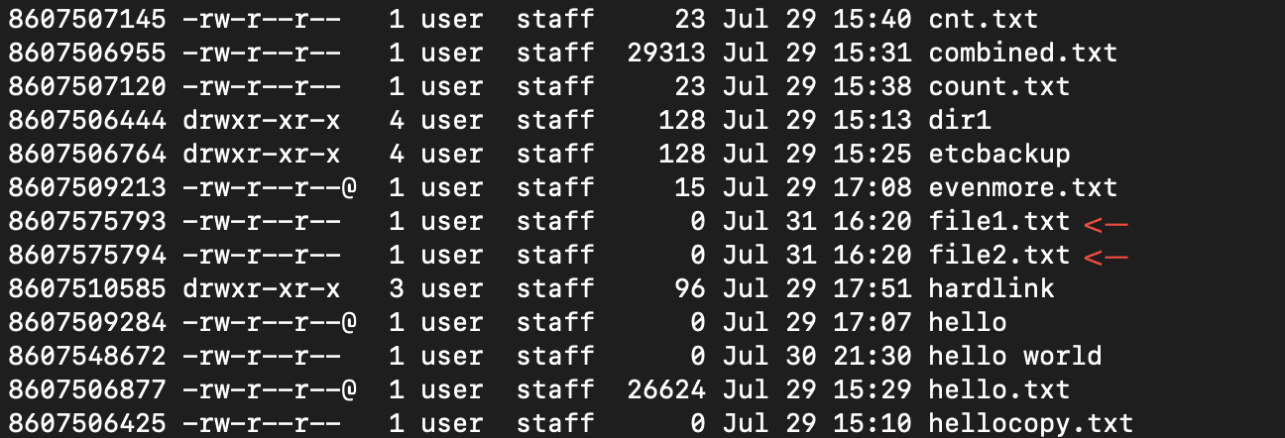

Now let’s soft link them using following cmd

user$ ln –s file1.txt file2.txt

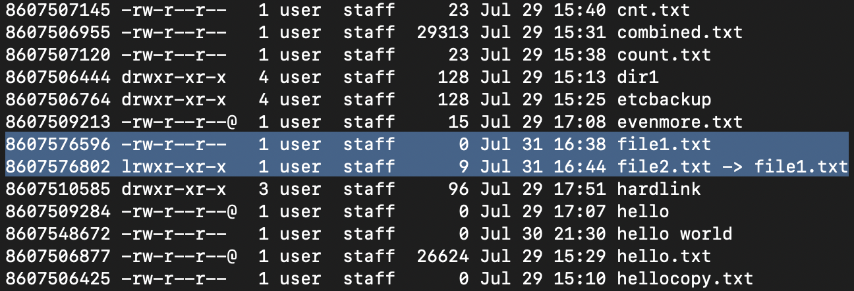

Here, we see both file1 and file2 have different inode numbers and file permissions and file2 points to file1

Now, if we delete the source file i.e file1.txt

user$ rm file1.txt

The link between file2.txt and file1.txt still stays, but if we try to view th contents of file2.txt using cat we got the following error:

cat file2.txt

cat: file2.txt: No such file or directory

Hence, file2.txt becomes useless.

**Hard Links**

Let’s create two new files:

user$ touch file1.txt file2.txt

Now let’s see the current directory

user$ ls –li



Now let’s hard link them using following cmd

user$ ln file1.txt file2.txt

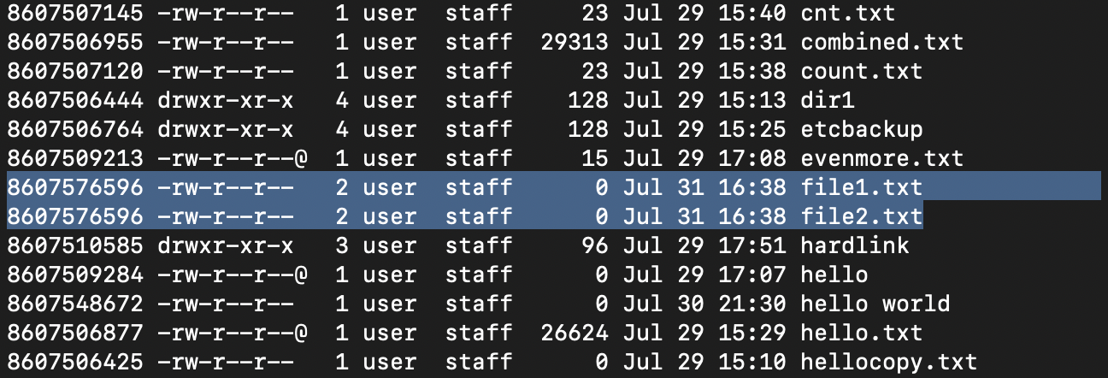

Here, both file1.txt and file2.txt have same inode number, same permissions and basically have same properties.

But the main difference is even we delete the source file here i.e. file1.txt file2.txt can still access to the contents that were inside of file1.txt and we won’t get any error upon accessing the contents of fil2.txt as we did in soft links.

We can simply access contents using:

cat file2.txt